Seared Tuna Sashimi
On a Bed of Sliced Celery, Beautified with Parsley and a Carrot Wasabi Stand
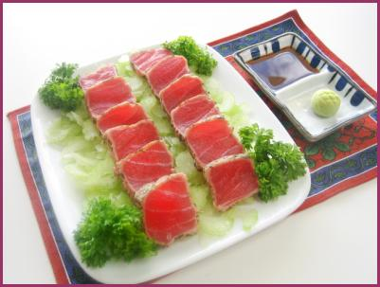

Materials
- 4 stalks of celery
- 2 springs of fresh parsley
- 1 carrot
- 1 package of Cryofresh Seared Sashimi Slices
- 1 vegetable slice
- 1 knife

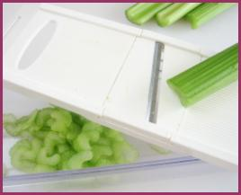
Instructions
- Select a plate approximately 8 inches square or round.
- Slice celery on a vegetable slicer.
- Arrange on the plate approximately 1 inch thick.
- Follow the thawing instruction on the seared tuna package.
- Arrange the seared tuna slices on the sliced celery.
- Garnish with parsley, a carrot wasabi stands, and a dish of soy sauce.

