Seared Tuna Sashimi
On a bed of Yellow Pepper, Garnished with Parsley and a Lemon Stand for Wasabi
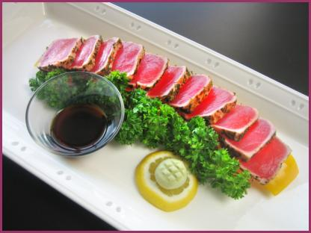
Preparation Guidelines

Materials
- 1 plate at least 14 inches long
- 1 yellow pepper at least 3 inches in diameter and as tall as possible
- 2 springs of fresh parsley
- 1 lemon
- 1 soy dish (see soy dishes)
- 1 package of Cryofresh Seared Sashimi Slices
- 1 knife

Instructions
- Cut off the top and bottom sections of the yellow pepper and remove seed core.
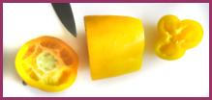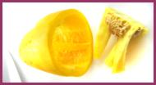

- Split the center section of the pepper with a knife, flatten the pepper, and trim into a configuration at least 10 inches long.
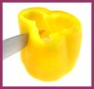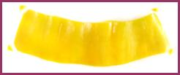

- Follow the thawing instruction on the seared tuna package, remove the tuna slices, and lay them on the yellow pepper. Overlap the slices enough so that a portion of the yellow pepper is visible on each end. .
- Garnish with parsley, wasabi on a lemon stand (see wasabi stands), and soy (see soy dishes).

